

**SOFTWARE RE-ENGINEERING**

**PROJECT REPORT**

**Student Management System**

**GROUP LEADER:**

**Taha Jawaid 21k-3881**

**GROUP MEMBER:**

**Israr Ali 21k-3840**

**Ahmad Noor Khan 21k-3841**

**Naresh Kumar 21k-3842**

**Introduction:**

Student Portal is a web-based application designed to streamline academic management by enabling seamless communication and record-keeping between students and teachers. The portal allows students to view academic records, register for courses, and generate transcripts, while teachers can manage student marks and attendance. The platform ensures secure, role-based access and aims to improve academic efficiency and transparency.

**Technologies Used:**

* **Frontend:** HTML, CSS, JavaScript
* **Backend:** Php
* **Database:** SQL (MySQL) with structured schema
* **Authentication:** Role-based login system with sessions or JWT

**Stakeholders:**

* **Students:** Access academic records, attendance, and course registration
* **Teachers:** Manage student marks, attendance, and transcripts
* **Administrators:** Oversee the portal’s operation, database integrity, and user management

**Project Scope:**

The Student Portal will offer the following core features:

* Secure login and role-based access for students and teachers
* Personalized dashboards for students and teachers
* Course registration and management
* Attendance and grade tracking
* SQL-backed data integrity and consistency

**Functional Requirements:**

**User Authentication and Profile Management**

* Secure login for students and teachers
* Role-based access (student vs teacher)
* Editable user profiles (limited fields)

**Student Dashboard**

* View attendance and grades
* Course registration system
* View transcript (auto-generated)

**Teacher Dashboard**

* Add or update student marks
* Record and manage attendance
* Access course rosters

**Admin Dashboard**

* Add or update or delete student
* Add or update or delete teacher
* Assign a course to teacher

**Course Management**

* Register and unregister courses (students)

**Security and Data Integrity**

* Enforced access restrictions (students can’t edit grades)
* SQL-based secure data operations

**User Interface**

* Intuitive and clean design
* Web Based Application

**User Stories:**

**Authentication & Account Management**

1. As a user (admin, teacher, or student), I want to securely log in and log out so that my account and data remain protected.
2. As an admin, I can add, delete, or update student accounts so that only active students can access the portal.
3. As an admin, I can add, delete, or update teacher accounts so that the staff list remains current.
4. As an admin, I can manage courses (add/delete) so that the curriculum reflects the current semester.

**Course Management**

1. As a student, I can register for available courses so that I can participate in them.
2. As an admin, I can assign courses to teachers so that they can manage their classes effectively.
3. As a teacher, I can add or update student marks so that grades are accurately reflected.

**Academic Records (Marks & Attendance)**

1. As a teacher, I can mark student attendance so that class participation is recorded.
2. As a student, I want to view my grades so that I can monitor my academic performance.
3. As a student, I want to view my attendance record so that I stay informed about my presence in classes.

**Use Case:**

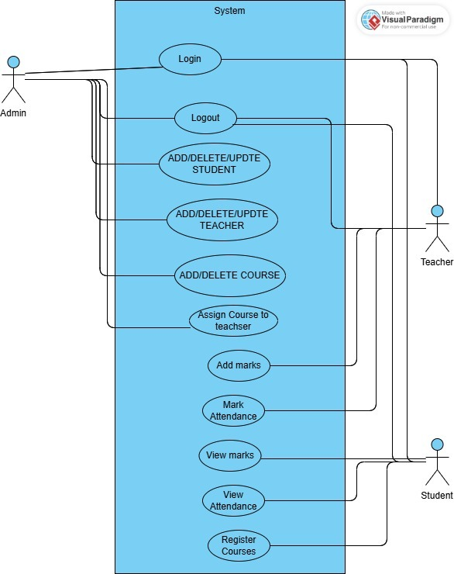

**Use Case Description:**

**UC1: User Login and Role-Based Access**

* **Actor:** Admin / Teacher / Student
* **Precondition:** User account must exist in the system
* **Main Flow:**
  + User navigates to the login page
  + User enters email and password
  + System verifies credentials
  + System identifies user role (admin, teacher, student)
  + System redirects user to their respective dashboard
* **Postcondition:** User is logged in with appropriate role-based access

**UC2: Student & Teacher Management**

* **Actor:** Admin
* **Precondition:** Admin is logged in
* **Main Flow:**
  + Admin selects add/update/delete option
  + Admin provides relevant data (e.g., name, ID, department)
  + System validates input
  + System updates database with new or modified user record
* **Postcondition:** Student or teacher record is created, updated, or deleted

**UC3: Course Management and Assignment**

* **Actor:** Admin
* **Precondition:** Admin is logged in
* **Main Flow:**
  + Admin adds or deletes courses
  + Admin selects a course and assigns it to a teacher
  + System verifies the teacher and course exist
  + System saves the course-teacher assignment
* **Postcondition:** Course is added/deleted or assigned to a teacher

**UC4: Course Registration**

* **Actor:** Student
* **Precondition:** Student is logged in
* **Main Flow:**
  + Student accesses course registration page
  + System displays available courses
  + Student selects desired courses
  + System validates selections
  + System updates student’s registered course list
* **Postcondition:** Student is registered in selected courses

**UC5: Attendance Management**

* **Actor:** Teacher / Student
* **Precondition:** Teacher is assigned to a course
* **Main Flow (Teacher):**
  + Teacher selects course and session date
  + Teacher marks attendance (present/absent) for students
  + System stores attendance data
* **Main Flow (Student):**
  + Student views attendance record from dashboard
* **Postcondition:** Attendance is recorded and visible to students

**UC6: Marks Management**

* **Actor:** Teacher / Student
* **Precondition:** Teacher is assigned to a course
* **Main Flow (Teacher):**
  + Teacher selects a course and student
  + Teacher enters or updates marks
  + System saves marks in the database
* **Main Flow (Student):**
  + Student views grades via dashboard
* **Postcondition:** Marks are saved and accessible to students

**High-Level Design Diagrams**

**Domain Model Diagram**

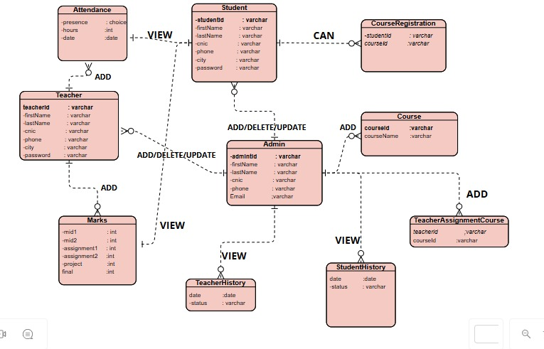

**System Sequence Diagram:**

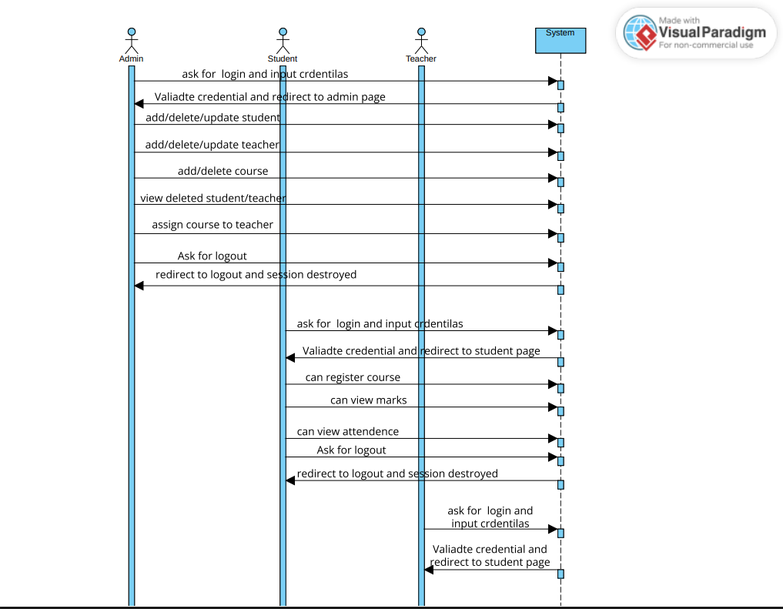

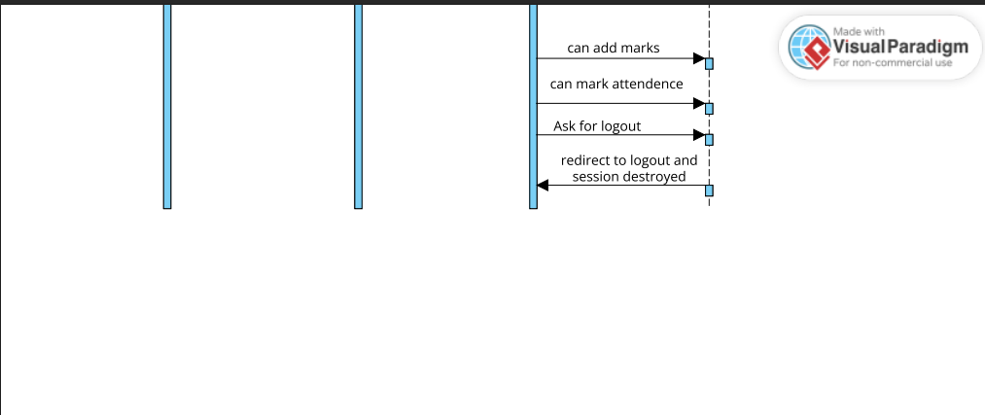

**Detailed Design**

**Class Diagram:**

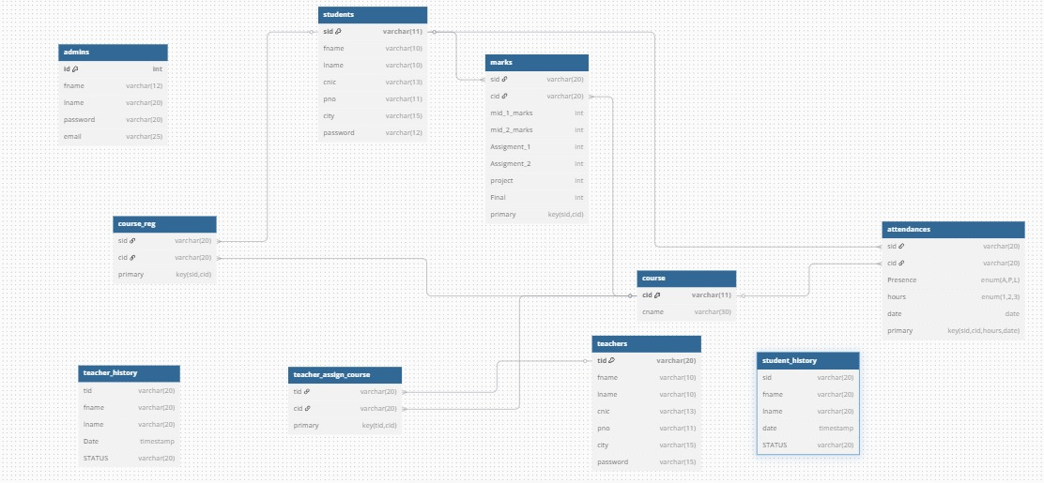

**Identify From Add Course Code**

<?php

$showAlert = false;

$showError = false;

if ($_SERVER["REQUEST_METHOD"] == "POST") {

    include 'partial/dbconnect.php';

    @$cid = $_POST["cid"];

    @$cname = $_POST["cname"];

    $sql = "INSERT INTO `course` (`cid`, `cname`) VALUES (?, ?)";

    $stmt = mysqli_prepare($conn, $sql);

    if ($stmt) {

        mysqli_stmt_bind_param($stmt, "ss", $cid, $cname);

        $result = mysqli_stmt_execute($stmt);

        if ($result) {

            $showAlert = true;

        } else {

            if (mysqli_errno($conn) == 1062) {

                $showError = "Course ID already exists. Please choose a different Course ID.";

            } else {

                $showError = "Error adding course record";

            }

        }

        mysqli_stmt_close($stmt);

    } else {

        $showError = "Error preparing statement";

    }

}

?>

<!DOCTYPE html>

<html lang="en">

  <head>

    <style>

        form{

            background:#333;

        }

        .mb-3{

            color:white;

        }

        .p-3{

            color:white;

        }

    </style>

    <meta charset="utf-8">

    <meta name="viewport" content="width=device-width, initial-scale=1, shrink-to-fit=no">

    <link rel="stylesheet" href="https://cdn.jsdelivr.net/npm/bootstrap@4.0.0/dist/css/bootstrap.min.css" integrity="sha384-Gn5384xqQ1aoWXA+058RXPxPg6fy4IWvTNh0E263XmFcJlSAwiGgFAW/dAiS6JXm" crossorigin="anonymous">

    <title>Add course</title>

  </head>

  <body background="images/908/sadmin.jpg" style="background-repeat: no-repeat;  height: 100%;background-position: center;background-repeat: no-repeat;background-size: cover;">

  <?php

        session_start();

        // $id = $_SESSION['id'];

  require 'partial/sidebar.php' ?>

<div class="container d-flex justify-content-center align-items-center" style="min-height: 80vh">

    <form class ="border shadow p-4 rounded "  action= "/dbproject/addcourse.php" method="post" style="width: 450px;"  >

      <h4 class="text-center p-3">ADD Course</h4>

      <div class="mb-3">

      <label for="id" class="form-label" >Course ID</label>

      <input type="text" class="form-control" id="cid" placeholder="Enter User ID" name="cid" Required>

      </div>

     <div class="mb-3">

      <label for="fname" class="form-label" >Course Name</label>

      <input type="text" class="form-control" id="cname" placeholder="Enter First Name" name="cname" Required>

      </div>

      <div class="mb-3">

      <button type="submit" class="btn btn-primary" name="submit" >ADD Course</button>

      </div>

     </form>

  </div>

    <script src="https://code.jquery.com/jquery-3.2.1.slim.min.js" integrity="sha384-KJ3o2DKtIkvYIK3UENzmM7KCkRr/rE9/Qpg6aAZGJwFDMVNA/GpGFF93hXpG5KkN" crossorigin="anonymous"></script>

    <script src="https://cdn.jsdelivr.net/npm/popper.js@1.12.9/dist/umd/popper.min.js" integrity="sha384-ApNbgh9B+Y1QKtv3Rn7W3mgPxhU9K/ScQsAP7hUibX39j7fakFPskvXusvfa0b4Q" crossorigin="anonymous"></script>

    <script src="https://cdn.jsdelivr.net/npm/bootstrap@4.0.0/dist/js/bootstrap.min.js" integrity="sha384-JZR6Spejh4U02d8jOt6vLEHfe/JQGiRRSQQxSfFWpi1MquVdAyjUar5+76PVCmYl" crossorigin="anonymous"></script>

 <?php

  if($showAlert){

    echo ' <div class="alert alert-success alert-dismissible fade show" role="alert">

        <strong>Success!</strong> new course added

        <button type="button" class="close" data-dismiss="alert" aria-label="Close">

            <span aria-hidden="true">×</span>

        </button>

    </div> ';

    }

    if($showError){

    echo ' <div class="alert alert-danger alert-dismissible fade show" role="alert">

        <strong>Error!</strong> '. $showError.'

        <button type="button" class="close" data-dismiss="alert" aria-label="Close">

            <span aria-hidden="true">×</span>

        </button>

    </div> ';}

   ?>

</body>

</html>

**1. Replicated Code**

* Bootstrap alerts are repeated in both success and error cases with minimal differences.

Php

echo ' <div class="alert alert-success ...">'; // success

echo ' <div class="alert alert-danger ...">'; // error

* Form control structure (labels + input) is hardcoded and can be modularized.
* mysqli_prepare, mysqli_stmt_bind_param, and mysqli_stmt_execute boilerplate could be abstracted into a reusable DB helper.

**2. Cohesion Issues**

* Low cohesion in PHP logic:
  + The script handles *database connection*, *form processing*, *session*, and *UI rendering* all in one file.
  + This violates the Single Responsibility Principle (SRP).
* Form and feedback logic (HTML + PHP) are tightly mixed.

**3. Coupling Issues**

* Tight coupling between:
  + Business logic and presentation.
  + Database schema (course table structure) and logic.
  + PHP and HTML code.
* dbconnect.php is coupled without error handling if the connection fails**.**

**Goals of Refactoring**

1. Separate logic (PHP), HTML (view), and database connection (model)
2. Remove duplication (like alert messages)
3. Improve naming and structure for maintainability

**Refactored Version (Same File, Better Structure)**

Here’s how to restructure the same code *within a single file* using functions, includes, and clearer separation:

**Refactored Code For Add Course Code**

**Php**

<?php

session_start();

// Include database connection

require_once 'partial/dbconnect.php';

require_once 'partial/sidebar.php';

$showAlert = false;

$showError = false;

// Utility function for inserting course

function addCourse($conn, $cid, $cname) {

$sql = "INSERT INTO course (cid, cname) VALUES (?, ?)";

$stmt = mysqli_prepare($conn, $sql);

if (!$stmt) return ["success" => false, "error" => "Error preparing statement"];

mysqli_stmt_bind_param($stmt, "ss", $cid, $cname);

if (mysqli_stmt_execute($stmt)) {

mysqli_stmt_close($stmt);

return ["success" => true];

} else {

$error = mysqli_errno($conn) == 1062

? "Course ID already exists. Please choose a different Course ID."

: "Error adding course record";

mysqli_stmt_close($stmt);

return ["success" => false, "error" => $error];

}

}

// Handle POST request

if ($_SERVER["REQUEST_METHOD"] == "POST") {

$cid = trim($_POST["cid"]);

$cname = trim($_POST["cname"]);

$result = addCourse($conn, $cid, $cname);

if ($result["success"]) {

$showAlert = true;

} else {

$showError = $result["error"];

}

}

?>

HTML

Html

<!DOCTYPE html>

<html lang="en">

<head>

<title>Add Course</title>

<meta charset="utf-8">

<meta name="viewport" content="width=device-width, initial-scale=1">

<!-- Bootstrap -->

<link rel="stylesheet" href="https://cdn.jsdelivr.net/npm/bootstrap@4.0.0/dist/css/bootstrap.min.css">

<style>

form { background: #333; }

.mb-3, .p-3 { color: white; }

</style>

</head>

<body background="images/908/sadmin.jpg" style="background-size: cover; background-repeat: no-repeat;">

<div class="container d-flex justify-content-center align-items-center" style="min-height: 80vh">

<form class="border shadow p-4 rounded" action="/dbproject/addcourse.php" method="post" style="width: 450px;">

<h4 class="text-center p-3">ADD Course</h4>

<div class="mb-3">

<label for="cid" class="form-label">Course ID</label>

<input type="text" class="form-control" id="cid" name="cid" placeholder="Enter Course ID" required>

</div>

<div class="mb-3">

<label for="cname" class="form-label">Course Name</label>

<input type="text" class="form-control" id="cname" name="cname" placeholder="Enter Course Name" required>

</div>

<div class="mb-3">

<button type="submit" class="btn btn-primary">ADD Course</button>

</div>

</form>

</div>

<!-- Alert messages -->

<?php if ($showAlert): ?>

<div class="alert alert-success alert-dismissible fade show" role="alert">

<strong>Success!</strong> New course added.

<button type="button" class="close" data-dismiss="alert"><span>&times;</span></button>

</div>

<?php endif; ?>

<?php if ($showError): ?>

<div class="alert alert-danger alert-dismissible fade show" role="alert">

<strong>Error!</strong> <?= htmlspecialchars($showError) ?>

<button type="button" class="close" data-dismiss="alert"><span>&times;</span></button>

</div>

<?php endif; ?>

<!-- JS -->

<script src="https://code.jquery.com/jquery-3.2.1.slim.min.js"></script>

<script src="https://cdn.jsdelivr.net/npm/bootstrap@4.0.0/dist/js/bootstrap.min.js"></script>

</body>

</html>

**Identify From Add Student Code**

<?php

$showAlert = false;

$showError = false;

if ($_SERVER["REQUEST_METHOD"] == "POST") {

    include 'partial/dbconnect.php';

    @$sid = $_POST["sid"];

    @$password = $_POST["password"];

    @$fname = $_POST["fname"];

    @$lname = $_POST["lname"];

    @$city = $_POST["city"];

    @$cnic = $_POST["cnic"];

    @$pno = $_POST["pno"];

    $sql = "INSERT INTO `students` (`sid`, `fname`, `password`, `lname`, `cnic`, `pno`, `city`) VALUES (?, ?, ?, ?, ?, ?, ?)";

    $stmt = mysqli_prepare($conn, $sql);

    if ($stmt) {

        mysqli_stmt_bind_param($stmt, "issssss", $sid, $fname, $password, $lname, $cnic, $pno, $city);

        $result = mysqli_stmt_execute($stmt);

        if ($result) {

            $showAlert = true;

        } else {

            if (mysqli_errno($conn) == 1062) {

                $showError = "User ID already exists. Please choose a different User ID.";

            } else {

                $showError = "Error adding student record";

            }

        }

        mysqli_stmt_close($stmt);

    } else {

        $showError = "Error preparing statement";

    }

}

?>

<!DOCTYPE html>

<html lang="en">

  <head>

    <style>

        form{

            background:#333;

        }

        .mb-3{

            color:white;

        }

        .p-3{

            color:white;

        }

    </style>

    <meta charset="utf-8">

    <meta name="viewport" content="width=device-width, initial-scale=1, shrink-to-fit=no">

    <link rel="stylesheet" href="https://cdn.jsdelivr.net/npm/bootstrap@4.0.0/dist/css/bootstrap.min.css" integrity="sha384-Gn5384xqQ1aoWXA+058RXPxPg6fy4IWvTNh0E263XmFcJlSAwiGgFAW/dAiS6JXm" crossorigin="anonymous">

    <title>Add student</title>

  </head>

  <body background="images/908/sadmin.jpg" style="background-repeat: no-repeat;  height: 100%;background-position: center;background-repeat: no-repeat;background-size: cover;">

  <?php

        session_start();

        // $id = $_SESSION['id'];

  require 'partial/sidebar.php' ?>

    <br>

    <br><br>

<div class="container d-flex justify-content-center align-items-center mb-5" style="min-height: 80vh">

    <form class ="border shadow p-4 rounded "  action= "/dbproject/adduser.php" method="post" style="width: 450px;"  >

      <h4 class="text-center p-3">Add Student</h4>

      <div class="mb-3">

      <label for="id" class="form-label" >User ID</label>

      <input type="text" class="form-control" id="sid" placeholder="Enter User ID" name="sid" Required>

      </div>

      <div class="mb-3">

      <label for="password" class="form-label" >Password</label>

      <input type="password" class="form-control" id="password" placeholder="Enter Password" name="password" Required>

      </div>

     <div class="mb-3">

      <label for="fname" class="form-label" >First Name</label>

      <input type="text" class="form-control" id="fname" placeholder="Enter First Name" name="fname" Required>

      </div>

     <div class="mb-3">

      <label for="lname" class="form-label" >Last Name</label>

      <input type="text" class="form-control" id="lname" placeholder="Enter Last Name" name="lname" Required>

      </div>

     <div class="mb-3">

      <label for="city" class="form-label" >city</label>

      <input type="text" class="form-control" id="city" placeholder="Enter City Name" name="city" Required>

      </div>

     <div class="mb-3">

      <label for="cnic" class="form-label" >Cnic</label>

      <input type="text" class="form-control" id="cnic" placeholder="Enter cnic" name="cnic" Required>

      </div>

     <div class="mb-3">

      <label for="phone" class="form-label" >Phone</label>

      <input type="text" class="form-control" id="pno" placeholder="Enter phone no" name="pno" Required>

      </div>

      <div class="mb-3">

      <button type="submit" class="btn btn-primary" name="submit" >ADD Student</button>

      </div>

     </form>

  </div>

    <script src="https://code.jquery.com/jquery-3.2.1.slim.min.js" integrity="sha384-KJ3o2DKtIkvYIK3UENzmM7KCkRr/rE9/Qpg6aAZGJwFDMVNA/GpGFF93hXpG5KkN" crossorigin="anonymous"></script>

    <script src="https://cdn.jsdelivr.net/npm/popper.js@1.12.9/dist/umd/popper.min.js" integrity="sha384-ApNbgh9B+Y1QKtv3Rn7W3mgPxhU9K/ScQsAP7hUibX39j7fakFPskvXusvfa0b4Q" crossorigin="anonymous"></script>

    <script src="https://cdn.jsdelivr.net/npm/bootstrap@4.0.0/dist/js/bootstrap.min.js" integrity="sha384-JZR6Spejh4U02d8jOt6vLEHfe/JQGiRRSQQxSfFWpi1MquVdAyjUar5+76PVCmYl" crossorigin="anonymous"></script>

  </body>

</html>

 <?php

  if($showAlert){

    echo ' <div class="alert alert-success alert-dismissible fade show" role="alert">

        <strong>Success!</strong> student record is added successfully !!!

        <button type="button" class="close" data-dismiss="alert" aria-label="Close">

            <span aria-hidden="true">×</span>

        </button>

    </div> ';

    }

    if($showError){

    echo ' <div class="alert alert-danger alert-dismissible fade show" role="alert">

        <strong>Error!</strong> '. $showError.'

        <button type="button" class="close" data-dismiss="alert" aria-label="Close">

            <span aria-hidden="true">×</span>

        </button>

    </div> ';}

   ?>

**1. Replicated Code**

* Bootstrap alerts reused through a helper.
* Form fields modularized via a loop or template function.
* MySQLI insert pattern abstracted.

**2. Cohesion Issues**

* Previously, DB logic, session, form processing, and UI were tightly packed.
* After refactor: logic, view, and DB concerns are separated in the same file using structured sections.

**3. Coupling Issues**

* Tight coupling between:
  + SQL and logic.
  + PHP/HTML.
  + UI and feedback.
* Now: handled with better structure and reusable helpers.

**Goals of Refactoring**

* Clear separation: logic, feedback, form rendering.
* Less duplication.
* Easier to maintain and scale.

**Refactor Code of addStudent**

Php

<?php

// ===== Logic Section =====

session_start();

require_once 'partial/dbconnect.php';

$showAlert = "";

$showError = "";

// Include reusable insert logic

function insertStudent($conn, $data) {

$sql = "INSERT INTO `students` (`sid`, `fname`, `password`, `lname`, `cnic`, `pno`, `city`) VALUES (?, ?, ?, ?, ?, ?, ?)";

$stmt = mysqli_prepare($conn, $sql);

if ($stmt) {

mysqli_stmt_bind_param($stmt, "issssss", $data['sid'], $data['fname'], $data['password'], $data['lname'], $data['cnic'], $data['pno'], $data['city']);

if (mysqli_stmt_execute($stmt)) {

mysqli_stmt_close($stmt);

return true;

} else {

$error = (mysqli_errno($conn) == 1062)

? "User ID already exists. Please choose a different User ID."

: "Error adding student record.";

}

mysqli_stmt_close($stmt);

} else {

$error = "Error preparing statement.";

}

return $error;

}

// Handle form POST

if ($_SERVER["REQUEST_METHOD"] == "POST") {

$studentData = [

'sid' => $_POST["sid"],

'fname' => $_POST["fname"],

'password' => $_POST["password"],

'lname' => $_POST["lname"],

'cnic' => $_POST["cnic"],

'pno' => $_POST["pno"],

'city' => $_POST["city"]

];

$result = insertStudent($conn, $studentData);

if ($result === true) {

$showAlert = "Student added successfully!";

} else {

$showError = $result;

}

}

?>

HTML

<!DOCTYPE html>

<html lang="en">

<head>

<title>Add Student</title>

<link rel="stylesheet" href="/assets/css/style.css">

<link rel="stylesheet" href="https://cdn.jsdelivr.net/npm/bootstrap@4.0.0/dist/css/bootstrap.min.css">

</head>

<body background="images/908/sadmin.jpg" style="background-size: cover;">

<?php include 'partial/sidebar.php'; ?>

<br><br>

<div class="container d-flex justify-content-center align-items-center mb-5" style="min-height: 80vh;">

<form class="border shadow p-4 rounded" action="/dbproject/addStudent.php" method="POST" style="width: 450px;">

<h4 class="text-center p-3">Add Student</h4>

<?php if ($showAlert): ?>

<div class="alert alert-success alert-dismissible fade show" role="alert">

<strong>Success!</strong> <?= htmlspecialchars($showAlert) ?>

<button type="button" class="close" data-dismiss="alert" aria-label="Close"><span>×</span></button>

</div>

<?php endif; ?>

<?php if ($showError): ?>

<div class="alert alert-danger alert-dismissible fade show" role="alert">

<strong>Error!</strong> <?= htmlspecialchars($showError) ?>

<button type="button" class="close" data-dismiss="alert" aria-label="Close"><span>×</span></button>

</div>

<?php endif; ?>

<!-- Reusable Form Fields -->

<?php

$fields = [

['name' => 'sid', 'label' => 'User ID', 'type' => 'text'],

['name' => 'password', 'label' => 'Password', 'type' => 'password'],

['name' => 'fname', 'label' => 'First Name', 'type' => 'text'],

['name' => 'lname', 'label' => 'Last Name', 'type' => 'text'],

['name' => 'city', 'label' => 'City', 'type' => 'text'],

['name' => 'cnic', 'label' => 'CNIC', 'type' => 'text'],

['name' => 'pno', 'label' => 'Phone', 'type' => 'text'],

];

foreach ($fields as $field):

?>

<div class="mb-3">

<label for="<?= $field['name'] ?>" class="form-label"><?= $field['label'] ?></label>

<input type="<?= $field['type'] ?>" class="form-control" id="<?= $field['name'] ?>" name="<?= $field['name'] ?>" placeholder="Enter <?= $field['label'] ?>" required>

</div>

<?php endforeach; ?>

<div class="mb-3">

<button type="submit" class="btn btn-primary" name="submit">Add Student</button>

</div>

</form>

</div>

<!-- Scripts -->

<script src="https://code.jquery.com/jquery-3.2.1.slim.min.js"></script>

<script src="https://cdn.jsdelivr.net/npm/bootstrap@4.0.0/dist/js/bootstrap.min.js"></script>

</body></html>

**Project Screen Student, Teacher and Admin**

